Introduction to xilinx ise and spartan 6 board
LAB # 03



Spring 2024
CSE-308L Digital System Design Lab

Submitted by: Ali Asghar
Registration No.: 21PWCSE2059
Class Section: C

“On my honor, as student of University of Engineering and Technology, I have neither given nor received unauthorized assistance on this academic work.”

Submitted to:
Dr. Asif Ali Khan

Date:
6th March 2024

Department of Computer Systems Engineering
University of Engineering and Technology, Peshawar
Objectives:
This lab will enable students to:
- Introduction to FPGA
- Introduction to Xilinx ISE

Software used:
- Xilinx ISE

Task 1:
Implement buffer ON the Kit and attach the snapshot.

Code:
DUT:
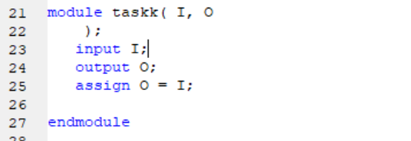

ucf file:
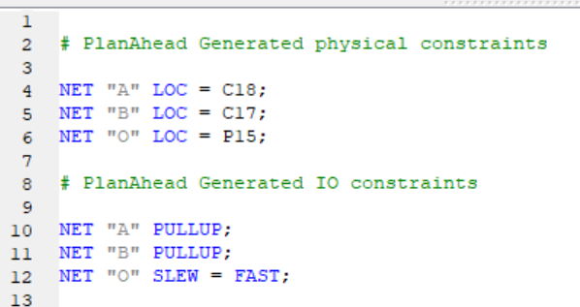

Output:
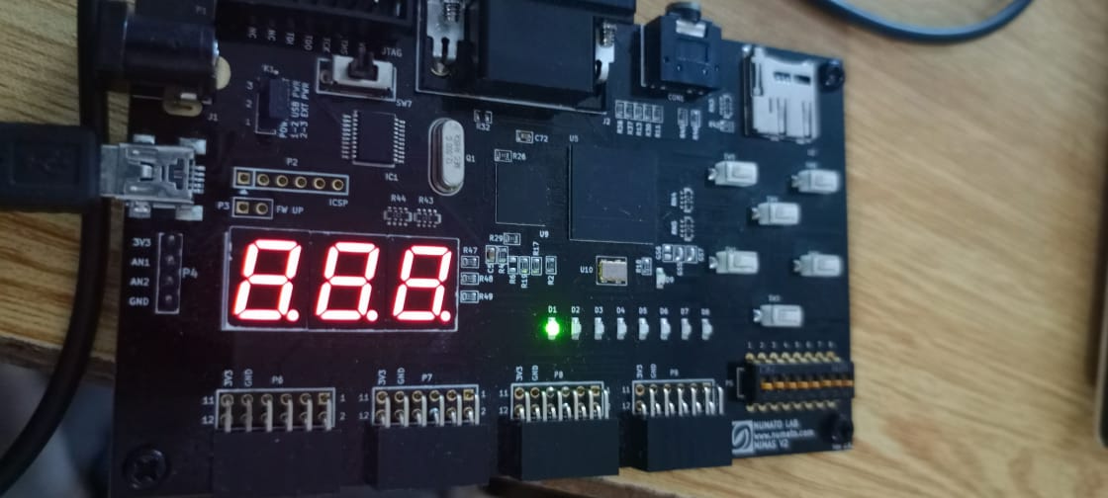
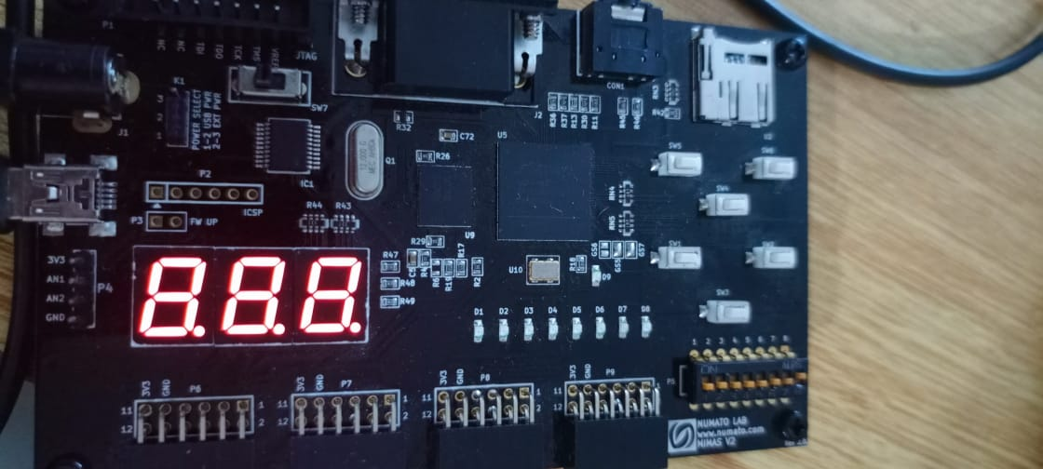

Task 2:
Implement AND/OR/XOR gate on the Kit and attach the snapshot.

Code:
DUT:
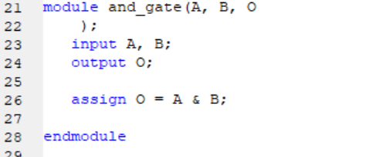

ucf file:
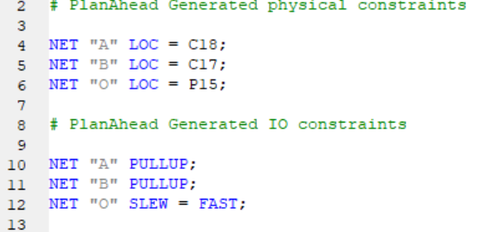

Output:
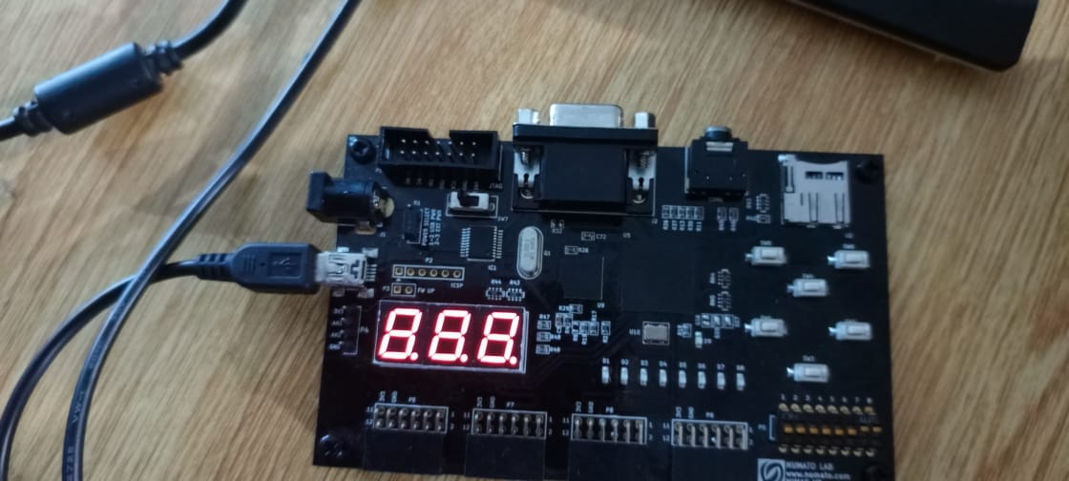
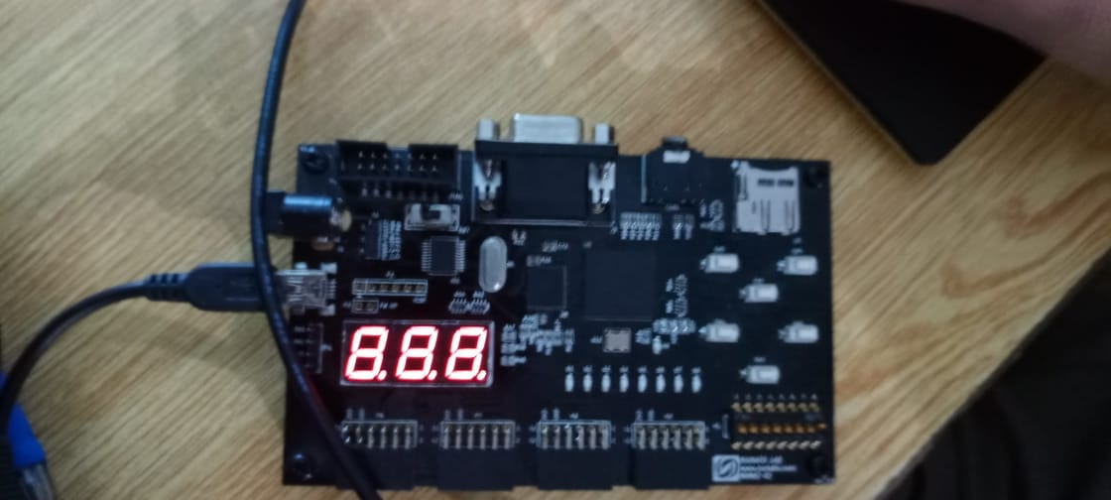

Task 3:
Implement OR gate using NAND gate.

Code:
DUT:
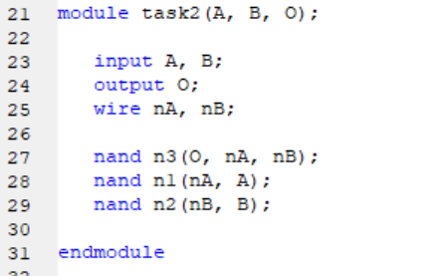

ucf file:
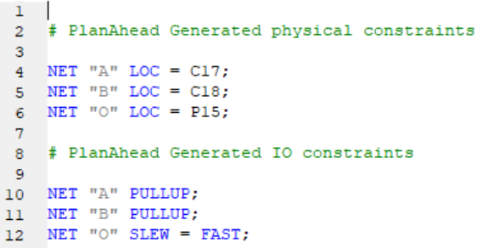

Output:
